 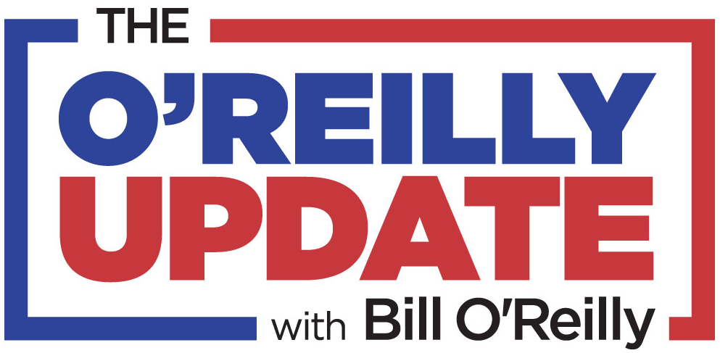

**Key Networks Signs Trailblazing Journalist and Author Bill O’Reilly For 15-Minute Daily Radio Program, “The O’Reilly Update”**

***“The O’Reilly Update” to Deliver ‘No Spin’ Analysis of People and Stories That Make America Great***

**NEW YORK, NY, and ORLANDO, FL, March 13, 2019** **–** [**Key Networks**](http://www.keynetworks.com), a next generation syndication company serving the radio industry, announces that it will syndicate a new 15-minute daily radio program, “The O’Reilly Update”, starring former cable news personality and bestselling author Bill O’Reilly. “The O’Reilly Update” cuts through the anonymous sources and phony stories dominating today’s news cycle and brings O’Reilly’s trademark “no spin” analysis to listeners across the U.S. in a high-impact format made for appointment listening. “The O’Reilly Update” marks a return to broadcast radio for O’Reilly, who hosted the nationally syndicated show, “The Radio Factor”, from 2002-2009.

Key Networks delivers “The O’Reilly Update” to stations of all formats and market sizes every weekday beginning at 11:30am EST. All advertising is included, with no additional barter units and 2 minutes of local avails in the feature.

Bill O’Reilly said: “More than ever before, Americans need accurate information and honest news analysis in order to make intelligent decisions. It is all about protecting yourself and your family. The daily *O’Reilly Update* will arm you with facts, and provide opinion based on those facts. Can’t wait to get started.”

Rob Koblasz, Chief Executive Officer, Key Networks, said: “Americans need straight talk now more than ever before. We are excited to make this 15-minute daily program available to radio stations across the U.S. *The O’Reilly Update* is tune-in listening at its best.”

Dennis Green, Chief Revenue Officer, Key Networks, said: “On the Mount Rushmore of spoken word talent you must include Bill O’Reilly. It’s an honor to bring Bill back to radio to deliver appointment listening and revenue opportunities for affiliate stations in a unique format. Attention stations: this program will provide the key (network) to your success!”

“The O’Reilly Update” will debut on Monday, April 29, 2019.

**For more information and to get “The O’Reilly Update” on your station, contact Dennis Green, Chief Revenue Officer, Key Networks, at 844.KEY.NETS or** [**dennis@keynetworks.com**](mailto:dennis@keynetworks.com)**.**

**About Bill O’Reilly**

Bill O'Reilly is a trailblazing TV journalist who has experienced unprecedented success on cable news and in writing fourteen national number-one bestselling nonfiction books. His ‘Killing’ series currently has more than 17 million books in print. He is currently the host of ‘No Spin News’ on BillOReilly.com. He lives on Long Island.

**About Key Networks**

Key Networks is a next generation syndication company serving the radio industry. Key Networks brings to radio an independent and dedicated team with more than 75 years of collective experience in radio programming, syndication, and marketing. By committing to a small and carefully crafted roster, Key Networks gives every show and partner the attention, service, and innovation they deserve. Our focus may be radio, but we are in the relationship business.

Key Networks is a [Sun & Fun Media](http://www.sunfunmedia.com) affiliated company and is based in Orlando, FL, and New York, NY. For more information, visit: [www.keynetworks.com](http://www.keynetworks.com).

###