 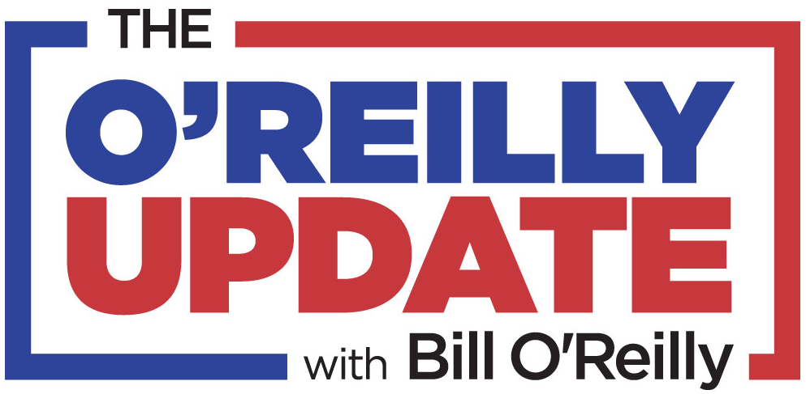

**Trailblazing Journalist and Author Bill O’Reilly Debuts 15-Minute Daily Radio Program, “The O’Reilly Update” This Week in Over 100 Markets Across the U.S.**

***Key Networks Brings O’Reilly’s Inimitable ‘No Spin’ Analysis of People and Stories That Make America Great to Cities From Coast-to-Coast***

**NEW YORK, NY, and ORLANDO, FL, May 1, 2019** **–** [**Key Networks**](http://www.keynetworks.com), a next generation syndication company serving the radio industry, announces the nationwide launch this week of the new 15-minute daily radio program, “The O’Reilly Update”, starring bestselling author and former #1 cable news personality Bill O’Reilly, on over 100 radio stations across the U.S. Among the show’s inaugural station affiliates are: WBAL, Baltimore, MD; WDTK, Detroit, MI: WHK, Cleveland, OH; KUFO, Portland, OR; and KTSA, San Antonio, TX. “The O’Reilly Update” hits the air in 4 of the top 10 DMA’s, 9 of the top 20 DMA’s and 18 of the top 50 DMA’s, and will be heard on stations across media companies including: Alpha Media, Beasley Media Group, Cox Media Group, Hubbard Broadcasting, iHeartMedia, Midwest Communications, Salem Media Group and Townsquare Media. Out of the more than 100 stations broadcasting “The O’Reilly Update”, 21 are non-News/Talk stations, including Country and Classic Hits stations. 67% of the new affiliates are heard on FM.

“The O’Reilly Update” cuts through the anonymous sources and phony stories dominating today’s news cycle and brings O’Reilly’s trademark “no spin” analysis to listeners across the U.S. in a unique format made for appointment listening. “The O’Reilly Update” marks a return to broadcast radio for O’Reilly, who hosted the nationally syndicated show, “The Radio Factor”, from 2002-2009.

Key Networks delivers “The O’Reilly Update” to stations of all market sizes every weekday beginning at 11:30am EST. All advertising is included, with no additional barter units and 2 minutes of local avails in the feature.

Bill O’Reilly said: “Polls show most Americans no longer trust the news media and with good reason; it’s hard to get accurate information. *The O’Reilly Update* will bring relief.  Solid facts, pithy analysis, important things you might not know - all will be part of the broadcast everyday. Plus, it’s fun to listen to.”

Rob Koblasz, Chief Executive Officer, Key Networks, said: “We are thrilled to partner with so many great radio stations across the U.S. to bring Bill O’Reilly back to radio.”

Dennis Green, Chief Revenue Officer, Key Networks, said: “The response to the return of Bill O’Reilly to radio with *The O’Reilly Update* has been phenomenal. Around the country from coast-to-coast, stations are delighted to have Bill’s voice delivering insightful and timely commentary on the news impacting our world!”

Cary Pahigian, President and General Manager, WBAL NewsRadio 1090 & FM 101.5 Baltimore, said: “Bill O’Reilly has a track record of insightful and unfiltered commentary on vital topics and issues. His familiar voice and dynamic point of view augments our lineup of outspoken hosts and commentators.”

Bruce Collins, News/Talk/Sports Content Director, Alpha Media USA/Portland, OR, said: "Bill is a true natural storyteller...I'm extremely excited to have him on-air in Portland on Freedom 970.”

**For more information and to get “The O’Reilly Update” on your station, contact Dennis Green, Chief Revenue Officer, Key Networks, at 844.KEY.NETS or** [**dennis@keynetworks.com**](mailto:dennis@keynetworks.com)**.**

**About Bill O’Reilly**

Bill O'Reilly is a trailblazing TV journalist who has experienced unprecedented success on cable news and in writing fourteen national number-one bestselling nonfiction books. His ‘Killing’ series currently has more than 17 million books in print. His current book *Killing the SS* is a NYT #1 bestseller and his highly anticipated *The United States of Trump* will be released this fall. He is currently the host of ‘No Spin News’ on BillOReilly.com. He lives on Long Island.

**About Key Networks**

Key Networks is a next generation syndication company serving the radio industry. Key Networks brings to radio an independent and dedicated team with more than 75 years of collective experience in radio programming, syndication, and marketing. By committing to a small and carefully crafted roster, Key Networks gives every show and partner the attention, service, and innovation they deserve. Our focus may be radio, but we are in the relationship business. Key Networks is a [Sun & Fun Media](http://www.sunfunmedia.com) affiliated company and is based in Orlando, FL, and New York, NY. For more information, visit: [www.keynetworks.com](http://www.keynetworks.com).

###