 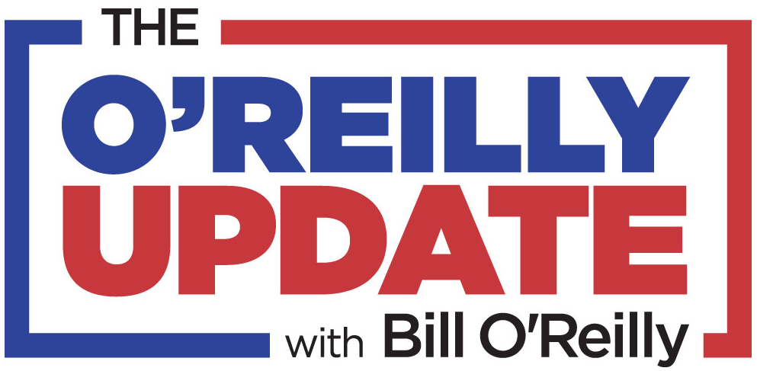

**Key Networks Brings Bill O’Reilly’s One-Hour Interview With President Donald Trump Exclusively to Radio Stations Across the U.S.**

* ***O’Reilly’s One-On-One Interview With President Trump to Air as a Market-Exclusive Special on Wednesday, November 27th and Throughout Thanksgiving Weekend***
* ***“The O’Reilly Update” One-Hour Special Available to Affiliate Stations and to Select Stations in Non-Affiliate Markets***
* ***O’Reilly Affiliates Can Expect First Crack at Additional Specials and Premium Content Throughout the 2020 Election Season***

**NEW YORK, NY, and ORLANDO, FL, November 12, 2019** **–** [**Key Networks**](http://www.keynetworks.com), a next generation syndication company serving the radio industry, announces that it will offer a one-hour Thanksgiving week radio special featuring bestselling author and former #1 cable news personality Bill O’Reilly’s exclusive one-on-one interview with President Donald Trump. The interview will provide listeners with insights from President Trump on the latest issues impacting the country as 2020 quickly approaches, and comes on the heels of the release of O’Reilly’s new book, *The United States of Trump: How the President Really Sees America*. O’Reilly also asks the President for his take on current events, the President’s campaign vision and what he is thankful for. Key Networks syndicates Bill O’Reilly’s 15-minute daily radio program, *The O’Reilly Update*, to nearly 200 radio stations across the U.S. The special is the first in a series of specials and exclusive content to be created especially for affiliates of *The O’Reilly Update* throughout the 2020 election season.

O’Reilly’s one-hour radio interview with President Trump will air as a market-exclusive special beginning Wednesday, November 27th and running throughout Thanksgiving weekend. The special - which O’Reilly has made exclusively for radio - is available to affiliates of *The O’Reilly Update*, O’Reilly’s 15-minute daily radio program nationally syndicated by Key Networks and airing in nearly 200 markets across the U.S. Key Networks will also make the Thanksgiving week special available to select stations in non-affiliate markets.

O’Reilly said: “The radio interview will cover the Trump administration’s triumphs and challenges including the unprecedented attacks on the President. We expect the talk to break news and be provocative from start to finish.”

Dennis Green, Chief Revenue Officer, Key Networks, said: “Key Networks is honored to provide Bill O’Reilly’s one-on-one interview with President Trump to stations around the country. The affiliates of *The O’Reilly Update* continue to get the best news and commentary for their listeners and access to O’Reilly’s No Spin analysis. If your station wants to win in 2020, they need to make O’Reilly a part of their lineup!”

*The O’Reilly Update* cuts through the anonymous sources and phony stories dominating today’s news cycle and brings O’Reilly’s trademark “no spin” analysis to listeners across the U.S. in a unique format made for appointment listening. *The O’Reilly Update* is now also available to affiliates in a special weekend edition and can be heard on smart speakers and on Pandora.

Key Networks delivers *The O’Reilly Update* to stations of all market sizes every weekday beginning at 11:30am EST. All advertising is included, with no additional barter units and 2 minutes of local avails in the feature.

**For more information and to get *The O’Reilly Update*’s one-hour Thanksgiving week special featuring O’Reilly’s exclusive interview with President Trump on your station, contact Dennis Green, Chief Revenue Officer, Key Networks, at 844.KEY.NETS or** [**dennis@keynetworks.com**](mailto:dennis@keynetworks.com)**.**

**About Bill O’Reilly**

Bill O’Reilly’s success in broadcasting and publishing is unmatched. The iconic anchor of “The O'Reilly Factor” led the program to the status of the highest-rated cable news broadcast in the nation for 16 consecutive years. His website [BillOReilly.com](https://www.billoreilly.com/) is followed by millions all over the world. “The O’Reilly Update” is heard on almost 200 radio affiliates. In addition, he has authored an astonishing 15 number one ranked non-fiction books including the historical “Killing” series.  Mr. O’Reilly currently has 17 million books in print. He has been a broadcaster for 45 years. He has been awarded three Emmy’s and a number of other journalism accolades. He was a national correspondent for CBS News and for ABC News as well as a reporter-anchor for WCBS-TV in New York City among other high-profile jobs. Mr. O'Reilly received two other Emmy nominations for the movies “Killing Kennedy” and “Killing Jesus.” He holds a history degree from Marist College, a master’s degree in Broadcast Journalism from Boston University, and another master’s degree from Harvard’s John F. Kennedy School of Government. Bill O’Reilly lives on Long Island where he was raised.  His philanthropic enterprises have raised tens of millions for people in need and wounded American veterans.

**About Key Networks**

Key Networks is a next generation syndication company serving the radio industry. Key Networks brings to radio an independent and dedicated team with more than 75 years of collective experience in radio programming, syndication, and marketing. By committing to a small and carefully crafted roster, Key Networks gives every show and partner the attention, service, and innovation they deserve. Our focus may be radio, but we are in the relationship business. Key Networks is a [Sun & Fun Media](http://www.sunfunmedia.com) affiliated company and is based in Orlando, FL, and New York, NY. For more information, visit: [www.keynetworks.com](http://www.keynetworks.com).

###